Transformation of plane stress
It has been discussed in the beginning that when the stress values are specified, the planes on which they act should also be specified. There are infinite number of planes passing through a point. Hence, to completely define the state of stress at a point, the stress information in all these planes is required. But it has also been demonstrated that if the stress values on three mutually perpendicular planes passing through a point are known, we can determine the stress on any other plane passing through that point.
There are many engineering problems where the state of stress at a point can be represented in a plane, which is known as a plane stress state (If the stresses are represented in $x-y$ plane as shown, there will not be stresses in the $z$-direction. All stresses are acting on planes parallel to the z-axis and no stresses are there on planes perpendicular to $z$-axis). Now let us consider the transformation of plane stress which will help us to find out the stresses in other planes passing through the point and parallel to the $z$-axis. It is equivalent to rotating the stress element with respect to $z$-axis as shown.
Let us find out the normal and shear stresses on a plane whose normal is along $x’$ which is making an angle $θ$ with the $x$-axis. Let the cube be cut by an inclined plane whose outward normal $x’$ makes an angle $θ$ with the $x$-axis.
 | 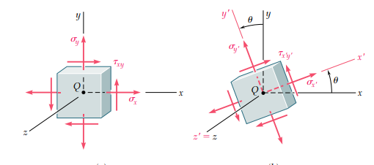
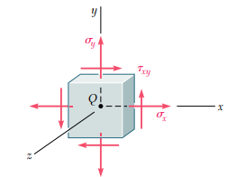 | 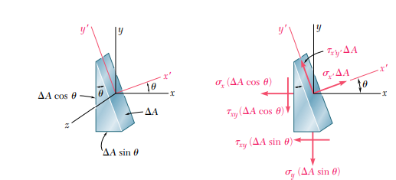 | 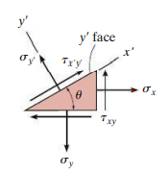
Consider the equilibrium of the left part. Let $∆A$be the area of the inclined surface. The area of the bottom face is $∆Asinsin θ$ and that of the left face is $∆Acoscos θ$
The normal and shear stresses on the inclined plane be $σ_{x^{'}x^{'}} and τ_{x^{'}y^{'}}$. The triangular prism is equilibrium under the action of the forces as shown. Writing down the equations of equilibrium along $x’$ and$y’$,

$ΣF_{x^{'}}=0 ≫≫$
$σ_{x^{'}x^{'}}∆A-{(σ}_{xx}∆Acoscos θ ) coscos θ -{(σ}_{yy}∆Asinsin θ ) sinsin θ -{(τ}_{xy}∆Asinsin θ )coscos θ -{(τ}_{xy}∆Acoscos θ )sinsin θ =0$
$σ_{x^{'}x^{'}}=σ_{xx}θ +σ_{yy}θ +τ_{xy}2sinsin θ coscos θ =σ_{xx}θ +σ_{yy}θ +τ_{xy}sinsin 2θ$
$σ_{x^{'}x^{'}}=σ_{xx}\left(\frac{1+coscos 2θ }{2}\right)+σ_{yy}\left(\frac{1-coscos 2θ }{2}\right)+τ_{xy}sinsin 2θ =\left(\frac{σ_{xx}+σ_{yy}}{2}\right)+\left(\frac{σ_{xx}-σ_{yy}}{2}\right)coscos 2θ +τ_{xy}sinsin 2θ$
$ΣF_{y^{'}}=0 ≫≫$
$τ_{x^{'}y^{'}}∆A+{(σ}_{xx}∆Acoscos θ ) sinsin θ -{(σ}_{yy}∆Asinsin θ ) coscos θ +{(τ}_{xy}∆Asinsin θ )sinsin θ -{(τ}_{xy}∆Acoscos θ )coscos θ =0$
$τ_{x^{'}y^{'}}={-(σ}_{xx}-σ_{yy})sinsin θ coscos θ +τ_{xy}(θ -θ )=-\left(\frac{σ_{xx}-σ_{yy}}{2}\right)sinsin 2θ +τ_{xy}coscos 2θ$
The normal stress on the plane whose outward normal is along the $y’$ axis can be obtained by substituting the $θ=θ+90$
$σ_{y^{'}y^{'}}=\left(\frac{σ_{xx}+σ_{yy}}{2}\right)+\left(\frac{σ_{xx}-σ_{yy}}{2}\right)coscos 2(90+θ) +τ_{xy}sinsin 2(90+θ) =\left(\frac{σ_{xx}+σ_{yy}}{2}\right)-\left(\frac{σ_{xx}-σ_{yy}}{2}\right)coscos 2θ -τ_{xy}sinsin 2θ$
We can see that,
$σ_{x^{'}x^{'}}+σ_{y^{'}y^{'}}=σ_{xx}+σ_{yy}$
The values of normal stress and shear stress change with the orientation ($θ$) of the planes. The normal stress will be maximum (or minimum) when,
$\frac{d}{dθ}\left(σ_{x^{'}x^{'}}\right)=0 ≫≫ \left(\frac{σ_{xx}-σ_{yy}}{2}\right)2θ )+τ_{xy}2θ =0$
$tantan 2θ_{p} =\frac{τ_{xy}}{\left(\frac{σ_{xx}-σ_{yy}}{2}\right)}$
The maximum value of normal stress,
$σ_{11}=\left(\frac{σ_{xx}+σ_{yy}}{2}\right)+\left(\frac{σ_{xx}-σ_{yy}}{2}\right)coscos 2θ_{p} +τ_{xy}sinsin 2θ_{p}$
$=\left(\frac{σ_{xx}+σ_{yy}}{2}\right)+\frac{\left(\frac{σ_{xx}-σ_{yy}}{2}\right)\left(\frac{σ_{xx}-σ_{yy}}{2}\right)}{\sqrt{{\left(\frac{σ_{xx}-σ_{yy}}{2}\right)}^{2}+{τ_{xy}}^{2}}}+\frac{τ_{xy}τ_{xy}}{\sqrt{{\left(\frac{σ_{xx}-σ_{yy}}{2}\right)}^{2}+{τ_{xy}}^{2}}}$
$σ_{11}=\left(\frac{σ_{xx}+σ_{yy}}{2}\right)+\sqrt{{\left(\frac{σ_{xx}-σ_{yy}}{2}\right)}^{2}+{τ_{xy}}^{2}}$
The minimum value of the normal stress,
$σ_{22}=\left(\frac{σ_{xx}+σ_{yy}}{2}\right)-\left(\frac{σ_{xx}-σ_{yy}}{2}\right)coscos 2θ_{p} -τ_{xy}sinsin 2θ_{p} =\left(\frac{σ_{xx}+σ_{yy}}{2}\right)-\frac{\left(\frac{σ_{xx}-σ_{yy}}{2}\right)\left(\frac{σ_{xx}-σ_{yy}}{2}\right)}{\sqrt{{\left(\frac{σ_{xx}-σ_{yy}}{2}\right)}^{2}+{τ_{xy}}^{2}}}-\frac{τ_{xy}τ_{xy}}{\sqrt{{\left(\frac{σ_{xx}-σ_{yy}}{2}\right)}^{2}+{τ_{xy}}^{2}}}$
$σ_{22}=\left(\frac{σ_{xx}+σ_{yy}}{2}\right)-\sqrt{{\left(\frac{σ_{xx}-σ_{yy}}{2}\right)}^{2}+{τ_{xy}}^{2}}$
The shear stress on these planes,
$τ_{12}=-\left(\frac{σ_{xx}-σ_{yy}}{2}\right)sinsin 2θ_{p} +τ_{xy}coscos 2θ_{p} =\frac{-\left(\frac{σ_{xx}-σ_{yy}}{2}\right)τ_{xy}}{\sqrt{{\left(\frac{σ_{xx}-σ_{yy}}{2}\right)}^{2}+{τ_{xy}}^{2}}}+\frac{\left(\frac{σ_{xx}-σ_{yy}}{2}\right)τ_{xy}}{\sqrt{{\left(\frac{σ_{xx}-σ_{yy}}{2}\right)}^{2}+{τ_{xy}}^{2}}}=0$
The planes on which the normal stresses are extremum (maximum or minimum) and the shear stresses are zero are known as principal planes. The maximum or minimum values of normal stresses are known as principal stresses.

The shear stress will be maximum when,
$\frac{d}{dθ}\left(τ_{x^{'}y^{'}}\right)=0 ≫≫ -\left(\frac{σ_{xx}-σ_{yy}}{2}\right)2θ )-τ_{xy}2θ =0$
$tantan 2θ_{s} =\frac{-\left(\frac{σ_{xx}-σ_{yy}}{2}\right)}{τ_{xy}}= -=-cotcot 2θ_{p} =tantan (90+2θ_{p} )$
$θ_{s}=θ_{p}+45°$
The maximum shear stress,
$τ_{max}=-\left(\frac{σ_{xx}-σ_{yy}}{2}\right)sinsin 2θ_{s} +τ_{xy}coscos 2θ_{s} =-\left(\frac{σ_{xx}-σ_{yy}}{2}\right)sinsin 2(θ_{p}+45°) +τ_{xy}coscos 2(θ_{p}+45°)$
$=\left\{-\left(\frac{σ_{xx}-σ_{yy}}{2}\right)coscos 2\left(θ_{p}\right) -τ_{xy}sinsin 2\left(θ_{p}\right) \right\}$
$τ_{max}=±\sqrt{{\left(\frac{σ_{xx}-σ_{yy}}{2}\right)}^{2}+{τ_{xy}}^{2}} =±\frac{{σ_{11}-σ}_{22}}{2}$
The value of normal stress on the planes of maximum shear stress
$=\left(\frac{σ_{xx}+σ_{yy}}{2}\right)+\left(\frac{σ_{xx}-σ_{yy}}{2}\right)coscos 2θ_{s} +τ_{xy}sinsin 2θ_{s} = \left(\frac{σ_{xx}+σ_{yy}}{2}\right)-\left(\frac{σ_{xx}-σ_{yy}}{2}\right)sinsin 2\left(θ_{p}\right) +τ_{xy}coscos 2\left(θ_{p}\right)$
$= \left(\frac{σ_{xx}+σ_{yy}}{2}\right)-\left(\frac{σ_{xx}-σ_{yy}}{2}\right)\frac{τ_{xy}}{\sqrt{{\left(\frac{σ_{xx}-σ_{yy}}{2}\right)}^{2}+{τ_{xy}}^{2}}} +τ_{xy}\frac{\left(\frac{σ_{xx}-σ_{yy}}{2}\right)}{\sqrt{{\left(\frac{σ_{xx}-σ_{yy}}{2}\right)}^{2}+{τ_{xy}}^{2}}}$
$σ_{ave}= \left(\frac{σ_{xx}+σ_{yy}}{2}\right)$

Plane stress | Normal and shear stresses on any plane
Principal stresses on principal planes | Normal and shear stresses on max shear stress planes

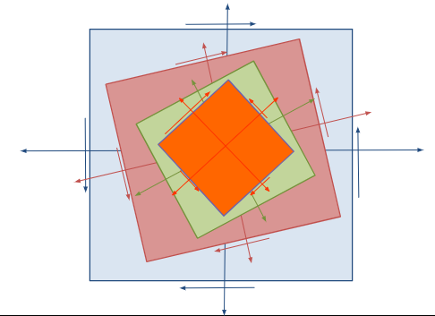

#Example 1
Uni-axial stress
What is the state of stress on any plane whose normal makes an angle of $30°$ with the x-axis? Also find the principal stresses and maximum shear stresses.
$σ_{x^{'}x^{'}}=\left(\frac{σ_{xx}+σ_{yy}}{2}\right)+\left(\frac{σ_{xx}-σ_{yy}}{2}\right)coscos 2θ +τ_{xy}sinsin 2θ$
$σ_{xx}=σ ≪≫σ_{yy}=0=τ_{xy}$
$σ_{x^{'}x^{'}}=\frac{σ}{2}+\frac{σ}{2}coscos 60 =0.75σ$
$σ_{y^{'}y^{'}}=\frac{σ}{2}-\frac{σ}{2}coscos 60 =0.25σ$
$τ_{x^{'}y^{'}}=-\left(\frac{σ_{xx}-σ_{yy}}{2}\right)sinsin 2θ +τ_{xy}coscos 2θ =-\frac{σ}{2}sinsin 60 =-0.43σ$
Principal stresses
$σ_{11,22}=\left(\frac{σ_{xx}+σ_{yy}}{2}\right)±\sqrt{{\left(\frac{σ_{xx}-σ_{yy}}{2}\right)}^{2}+{τ_{xy}}^{2}}=σ , 0$
Orientation of principal planes
$tantan 2θ_{p} =\frac{τ_{xy}}{\left(\frac{σ_{xx}-σ_{yy}}{2}\right)}=0 ≫2θ_{p}=0°, 180°$
$θ_{p}=0°, 90°$

Maximum shear stress plane
$θ_{s}=θ_{p}+45°=45°, 135°$
$τ_{max}=-\left(\frac{σ_{xx}-σ_{yy}}{2}\right)sinsin 2θ_{s} +τ_{xy}coscos 2θ_{s}$
$=-\frac{σ_{ }}{2}, +\frac{σ_{ }}{2}$
The normal stresses on planes of maximum shear stress,
$σ_{ave}= \left(\frac{σ_{xx}+σ_{yy}}{2}\right)=\frac{σ_{ }}{2}$

#Example 2
Pure shear
Consider a cylindrical bar subjected to a torque $T$. A point on the surface of the bar will be in a state of pure shear.
What is the state of stress on any plane whose normal makes an angle of $30°$ with the x-axis?
$σ_{x^{'}x^{'}}=\left(\frac{σ_{xx}+σ_{yy}}{2}\right)+\left(\frac{σ_{xx}-σ_{yy}}{2}\right)coscos 2θ +τ_{xy}sinsin 2θ$  $σ_{xx}=σ_{yy}=0 ≪≫τ_{xy}=τ$  $σ_{x^{'}x^{'}}=τ_{ }sinsin 60 =0.866τ$  $σ_{y^{'}y^{'}}=-τsinsin 60 =-0.866τ$  $τ_{x^{'}y^{'}}=-\left(\frac{σ_{xx}-σ_{yy}}{2}\right)sinsin 2θ +τ_{xy}coscos 2θ =τ_{ }coscos 60 =0.5τ$ | Principal stresses  $σ_{11,22}=\left(\frac{σ_{xx}+σ_{yy}}{2}\right)±\sqrt{{\left(\frac{σ_{xx}-σ_{yy}}{2}\right)}^{2}+{τ_{xy}}^{2}}=τ, -τ$  Orientation of principal planes  $tantan 2θ_{p} =\frac{τ_{xy}}{\left(\frac{σ_{xx}-σ_{yy}}{2}\right)}=∞$  $≫2θ_{p}=90°, 270°$  $θ_{p}=45°, 135°$
Maximum shear stress plane
$θ_{s}=θ_{p}+45°=90°, 180°$
$τ_{max}=-\left(\frac{σ_{xx}-σ_{yy}}{2}\right)sinsin 2θ_{s} +τ_{xy}coscos 2θ_{s} =±τ$
The normal stresses on planes of maximum shear stress,
$σ_{ave}= \left(\frac{σ_{xx}+σ_{yy}}{2}\right)=0$

#Example 3  The state of plane stress at a point on the surface of the airplane fuselage is represented on the element oriented as shown. Determine the state of stress at the point on an element that is oriented $30°$ as shown. Also determine the principal stresses and maximum shear stress. | 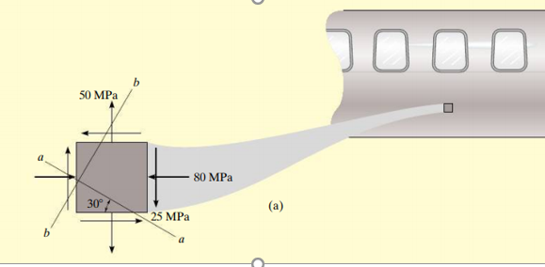
$σ_{xx}=-80 MPa, ≪≫ σ_{yy}=50 MPa ≪≫τ_{xy}=-25 MPa ≪≫ θ=60°$
$σ_{x^{'}x^{'}}=\left(\frac{σ_{xx}+σ_{yy}}{2}\right)+\left(\frac{σ_{xx}-σ_{yy}}{2}\right)coscos 2θ +τ_{xy}sinsin 2θ =\left(\frac{-80+50}{2}\right)+\left(\frac{-80-50}{2}\right)coscos 120 -25sinsin 120$
$σ_{x^{'}x^{'}}=-15+32.5-21.7=-4.15 MPa$
${σ_{x^{'}x^{'}}+σ}_{y^{'}y^{'}}=σ_{xx}+σ_{yy} ≪≫ σ_{y^{'}y^{'}} =-80+50+4.15=-25.85 MPa$
$τ_{x^{'}y^{'}}=-\left(\frac{σ_{xx}-σ_{yy}}{2}\right)sinsin 2θ +τ_{xy}coscos 2θ =-\left(\frac{-80-50}{2}\right)sinsin 120 -25coscos 120 =68.8 MPa$
Orientation of principal planes
$tantan 2θ_{p} =\frac{τ_{xy}}{\left(\frac{σ_{xx}-σ_{yy}}{2}\right)}=\frac{-25}{\left(\frac{-80-50}{2}\right)} ≫2θ_{p}=21°, 201°$
$θ_{p}=10.5°, 100.5°$
Principal stresses
$σ_{11,22}=\left(\frac{-80+50}{2}\right)±\sqrt{{\left(\frac{-80-50}{2}\right)}^{2}+{(-25)}^{2}}=-15±69.6=-84.6 MPa, +54.6 MPa$
Maximum shear stress plane
$θ_{s}=θ_{p}+45°=55.5°, 145.5°$
$τ_{max}=-\left(\frac{σ_{xx}-σ_{yy}}{2}\right)sinsin 2θ_{s} +τ_{xy}coscos 2θ_{s} =-\left(\frac{-80-50}{2}\right)sinsin 111 -25coscos 111 =69.6 MPa$
The normal stresses on planes of maximum shear stress,
$σ_{ave}= \left(\frac{σ_{xx}+σ_{yy}}{2}\right)=\left(\frac{-80+50}{2}\right)=-15 MPa$

Exercise 1  Determine the normal and shear stress acting on the plane AB. | 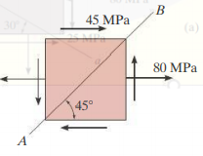
Exercise 2
The state of stress at a point in a material is shown in the following figures. Evaluate the mormal and shear stresses on a plane whose normal makes an angle $20°$ with the x-axis. Also, determine the principal stresses, orientation of principal planes, maximum in-plane shear stress and the corresponding plane.
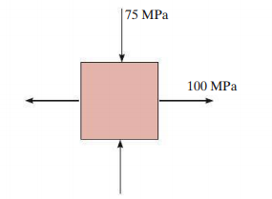 | 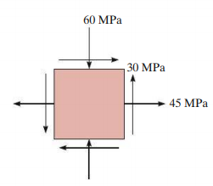
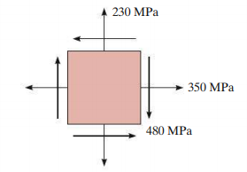 | 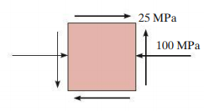

Transformation Equations for plain strain
$ε_{x^{'}x^{'}}=\left(\frac{ε_{xx}+ε_{yy}}{2}\right)+\left(\frac{ε_{xx}-ε_{yy}}{2}\right)coscos 2θ +ε_{xy}sinsin 2θ$
$ε_{y^{'}y^{'}}=\left(\frac{ε_{xx}+ε_{yy}}{2}\right)-\left(\frac{ε_{xx}-ε_{yy}}{2}\right)coscos 2θ -ε_{xy}sinsin 2θ$
$ε_{x^{'}y^{'}}=-\left(\frac{ε_{xx}-ε_{yy}}{2}\right)sinsin 2θ +ε_{xy}coscos 2θ$
Orientation of principal planes, $tantan 2θ_{p} =\frac{ε_{xy}}{\left(\frac{ε_{xx}-ε_{yy}}{2}\right)}$
Principal strains, $ε_{11,22}=\left(\frac{ε_{xx}+ε_{yy}}{2}\right)±\sqrt{{\left(\frac{ε_{xx}-ε_{yy}}{2}\right)}^{2}+{ε_{xy}}^{2}}$
Maximum shear strain, $γ_{max}=2 ε_{max}=±2\sqrt{{\left(\frac{ε_{xx}-ε_{yy}}{2}\right)}^{2}+{ε_{xy}}^{2}} =±2 \left(\frac{ε_{11}-ε_{22}}{2}\right)$

Reference:
- Mechanics of Materials, 2/e, J. M. Gere & S. P.Timoshenko, CBS Publishers.
- Mechanics of Materials, 6/e, F.P. Beer & E. R. Johnston, McGraw Hill
- Engineering Mechanics of Solids, 2/e, E. P. Popov, Pearson Education Asia.
- Mechanics of Materials, 9/e, R. C. Hibbeler, Prentice Hall.

